Answer
L1 : More about factorization (A)

Overview:

Which one(s) are the factors of 8?

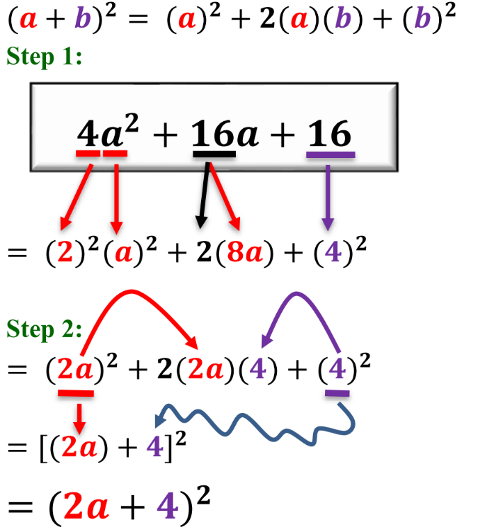
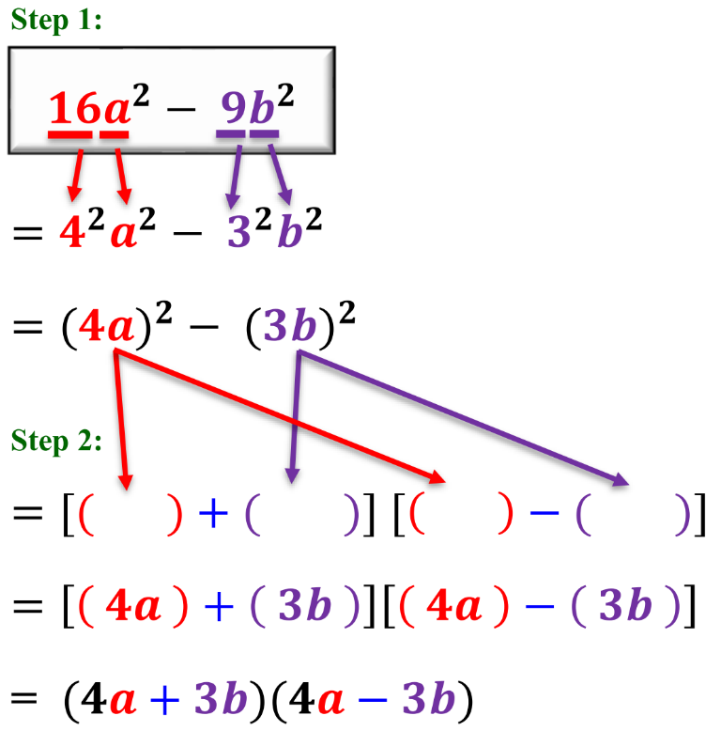
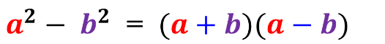
Factorize = Find the factors
∴答案格式一定係 ( )( )
8 = 1 x 8 = (1)(8)
8 = 2 x 4 = (2)(4)
Checkpoint 1

Checkpoint 2
$$a^{2}+2ab+b^{2}={(a+b)}^{2}$$

1
3
5
2
4
6
7
8
Let’s get started!

Factorize the following expressions.

1. $a^{\text{2}}+\text{4}a+\text{4}$

3. $\text{25}d^{\text{2}}+\text{20}d+\text{4}$

5. $\text{16}m^{\text{2}}+\text{8}mn+n^{\text{2}}$

7. 16a² − 1
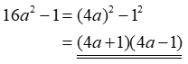

9. $\text{4}a^{\text{4}}-b^{\text{2}}c^{\text{2}}$

11. (a) Factorize 16x² − 8x + 1.
(b) Hence, factorize 16y⁴ − 8y² + 1.

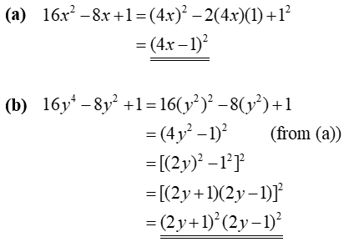

2. $\text{4}c^{\text{2}}-\text{12}c+\text{9}$

4. $\text{9}b^{\text{2}}-\text{6}b+\text{1}$

6. $p^{\text{2}}-\text{10}pq+\text{25}q^{\text{2}}$

8. $\text{36}m^{\text{2}}-\text{25}n^{\text{2}}$

10. 32x² − 50y²

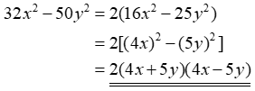

12. (a) Factorize 5x² + 20x + 20.
(b) Hence, factorize 5x² + 20x − 25.

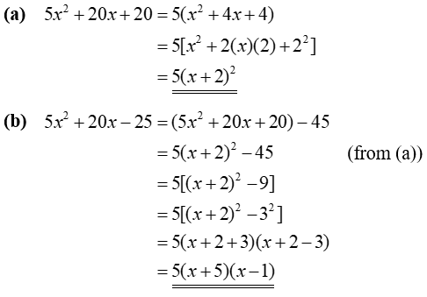

You have learnt more!
Go on!
$$x^{2}$$
$$x$$
$$x$$

$$2$$
$$+2$$
$$+1$$

$$x$$
$$x$$

$$+2$$
$$+1$$

$$(x+2)$$
$$(x+1)$$
$$x^{2}+3x+2= (x+2)(x+1)$$

$$x$$
$$x$$

$$+2$$
$$+1$$

Multiply
1
2
$$\left(x\right)\left(+1\right)$$
$$x$$
$$\left(x\right)\left(+2\right)$$
$$2x$$
$$+$$
$$=3x$$
$$x^{2}+3x+2$$

Factorize the following expressions.
Checkpoint 3
Factorize x² + 3x + 2

13. $x^{\text{2}}+\text{4}x+\text{3}$

$$\left(x+\text{1}\right)\left(x+\text{3}\right)$$

15. $a^{\text{2}}+\text{6}a+\text{5}$

$$\left(a+\text{1}\right)\left(a+\text{5}\right)$$

17. $c^{\text{2}}+\text{5}c+\text{6}$

$$\left(c+\text{2}\right)\left(c+\text{3}\right)$$

19. $p^{\text{2}}+\text{8}pq+\text{15}q^{\text{2}}$

$$\left(p+\text{3}q\right)\left(p+\text{5}q\right)$$

21. $a^{\text{2}}+\text{13}ab+\text{30}b^{\text{2}}$

$$\left(a+\text{3}b\right)\left(a+\text{10}b\right)$$

14. $y^{\text{2}}+\text{8}y+\text{7}$

$$\left(y+\text{1}\right)\left(y+\text{7}\right)$$

16. $b^{\text{2}}+\text{12}b+\text{11}$

$$\left(b+\text{1}\right)\left(b+\text{11}\right)$$

18. $d^{\text{2}}+\text{7}d+\text{10}$

$$(d+\text{2})(d+\text{5})$$

20. $m^{\text{2}}+\text{12}mn+\text{35}n^{\text{2}}$

$$\left(m+\text{5}n\right)\left(m+\text{7}n\right)$$

22. $x^{\text{2}}+\text{17}xy+\text{30}y^{\text{2}}$

$$\left(x+\text{2}y\right)\left(x+\text{15}y\right)$$

$$x^{2}$$
$$x$$
$$x$$

$$2$$
$$+2$$ | $$-2$$
$$+1$$ | $$-1$$

$$x$$
$$x$$

$$-2$$
$$-1$$

$$(x-2)$$
$$(x-1)$$
$$x^{2}-3x+2= (x-2)(x-1)$$

$$x$$
$$x$$

$$-2$$
$$-1$$

Multiply
1
2
$$\left(x\right)\left(-1\right)$$
($-x$)
$$\left(x\right)\left(-2\right)$$
($-2x$)
$$+$$
$$=-3x$$
$$x^{2}-3x+2$$

Keep Fighting!

Factorize the following expressions.
Checkpoint 4
Factorize x² - 3x + 2

23. $x^{\text{2}}-\text{14}x+\text{13}$

$$\left(x-\text{1}\right)\left(x-\text{13}\right)$$

25. $w^{\text{2}}-\text{8}w+\text{12}$

$$\left(w-\text{2}\right)\left(w-\text{6}\right)$$

27. $p^{\text{2}}-\text{11}p+\text{2}\text{8}$

$$\left(p-\text{4}\right)\left(p-\text{7}\right)$$

29. $r^{\text{2}}-\text{9}rs+\text{20}s^{\text{2}}$

$$\left(r-\text{4}s\right)\left(r-\text{5}s\right)$$

31. $s^{\text{2}}-\text{19}st+\text{70}t^{\text{2}}$

$$\left(s-\text{5}t\right)\left(s-\text{14}t\right)$$

24. $y^{\text{2}}-\text{13}y+\text{12}$

$$\left(y-\text{1}\right)\left(y-\text{12}\right)$$

26. $z^{\text{2}}-\text{7}z+\text{12}$

$$\left(z-\text{3}\right)\left(z-\text{4}\right)$$

28. $q^{\text{2}}-\text{16}q+\text{28}$

$$\left(q-\text{2}\right)\left(q-\text{14}\right)$$

30. $a^{\text{2}}-\text{18}ab+\text{56}b^{\text{2}}$

$$\left(a-\text{4}b\right)\left(a-\text{14}b\right)$$

32. $α^{\text{2}}-\text{16}αβ+\text{48}β^{\text{2}}$

$$\left(α-\text{4}β\right)\left(α-\text{12}β\right)$$

Factorize the following expressions.
33. $a^{\text{2}}+\text{5}a+\text{6}$

$$\left(a+\text{2}\right)\left(a+\text{3}\right)$$

35. $b^{\text{2}}-\text{12}b+\text{27}$

$$\left(b-\text{3}\right)\left(x-\text{9}\right)$$

37. $x^{\text{2}}-\text{15}x+\text{36}$

$$\left(x-\text{3}\right)\left(x-\text{12}\right)$$

39. $m^{\text{2}}-\text{10}mk+\text{21}k^{\text{2}}$

$$\left(m-\text{3}k\right)\left(m-\text{7}k\right)$$

41. $s^{\text{2}}+\text{1}\text{5}st+\text{26}t^{\text{2}}$

$$\left(s+\text{2}t\right)\left(s+\text{1}\text{3}t\right)$$

43. $\text{5}c^{\text{2}}-\text{40}cd+\text{75}d^{\text{2}}$

$$\text{5}\left(c-\text{3}d\right)\left(c-\text{5}d\right)$$

45. $u^{\text{2}}t^{\text{2}}+\text{13}uvt+\text{22}v^{\text{2}}$

$$\left(ut+\text{2}v\right)\left(ut+\text{11}v\right)$$

34. $a^{\text{2}}+\text{5}+\text{6}a$

$$\left(a+\text{1}\right)\left(a+\text{5}\right)$$

36. $\text{3}b^{\text{2}}-\text{36}b+\text{81}$

$$\text{3}\left(b-\text{3}\right)\left(b-\text{9}\right)$$

38. $\text{2}x^{\text{2}}+\text{30}x+\text{72}$

$$\text{2}\left(x+\text{3}\right)\left(x+\text{12}\right)$$

40. $m^{\text{2}}n-\text{10}mnk+\text{21}k^{\text{2}}n$

$$n\left(m-\text{3}k\right)\left(m-\text{7}k\right)$$

42. $26s^{\text{2}}-\text{1}\text{5}st+t^{\text{2}}$

$$\left(t-\text{2}s\right)\left(t-\text{1}\text{3}s\right)$$

44. $p^{\text{3}}+\text{1}\text{8}p^{\text{2}}t+\text{45}pt^{\text{2}}$

$$p\left(p+\text{3}t\right)\left(p+\text{15}t\right)$$

46. $x^{\text{4}}-\text{16}x^{\text{2}}y^{\text{2}}+\text{63}y^{\text{4}}$

$$\left(x^{\text{2}}-\text{7}y^{\text{2}}\right)\left(x^{\text{2}}-\text{9}y^{\text{2}}\right) \\ =\left(x^{\text{2}}-\text{7}y^{\text{2}}\right)\left(x+\text{3}y\right)\left(x-\text{3}y\right)$$

Give it a try


Final Ans:
$$x^{2}+2x-3=(x+3)(x-1)$$
$$x^{2}$$
$$x$$
$$x$$

$$-3$$
$$+3$$ | $$-3$$
$$-1$$ | $$+1$$

$$x$$
$$x$$

$$-3$$
$$+1$$

Multiply
1
2
$$\left(x\right)\left(+1\right)$$
($x$)
$$\left(x\right)\left(-3\right)$$
($-3x$)
$$+$$
$$=-2x$$
$$x^{2}+2x+3$$

Trial 2
$$x^{2}$$
$$x$$
$$x$$

$$-3$$
$$+3$$ | $$-3$$
$$-1$$ | $$+1$$

$$x$$
$$x$$

$$+3$$
$$-1$$

Multiply
1
2
$$\left(x\right)\left(-1\right)$$
($-x$)
$$\left(x\right)\left(+3\right)$$
($3x$)
$$+$$
$$=2x$$
$$x^{2}+2x+3$$

Trial 1
Checkpoint 5
Factorize $x^{2}+2x-3$
最尾係正, 正正負負
最尾係負, 正負正負
$(a+1)(a+2)$ $(a-1)(a-2)$ $(a+1)(a-2)$

Expand the following expressions.

Factorize the following expressions.
47. $x^{\text{2}}+\text{2}x-\text{3}$

$$(x+\text{3})(x-\text{1})$$

49. $y^{\text{2}}+\text{3}y-\text{10}$

$$(y+\text{5})(y-\text{2})$$

51. $h^{\text{2}}-\text{14}h-\text{51}$

$$(h+\text{3})(h-\text{17})$$

53. $r^{\text{2}}-\text{8}r-\text{33}$

$$(r+\text{3})(r-\text{11})$$

55. $x^{\text{2}}-\text{11}xy-\text{42}y^{\text{2}}$

$$\left(x+\text{3}y\right)\left(x-\text{14}y\right)$$

57. $c^{\text{2}}+\text{19}cd-\text{120}d^{\text{2}}$

$$\left(c+\text{24}d\right)\left(c-\text{5}d\right)$$

48. $x^{\text{2}}-\text{2}x-\text{3}$

$$(x+\text{1})(x-\text{3})$$

50. $y^{\text{2}}-\text{3}y-\text{10}$

$$(y+\text{2})(y-\text{5})$$

52. $n^{\text{2}}+\text{16}n-\text{57}$

$$(n+\text{19})(n-\text{3})$$

54. $k^{\text{2}}+\text{3}k-\text{54}$

$$(k+\text{9})(k-\text{6})$$

56. $a^{\text{2}}-\text{9}ab-\text{52}b^{\text{2}}$

$$\left(a+\text{4}b\right)\left(a-\text{13}b\right)$$

58. $p^{\text{2}}+\text{14}pq-\text{72}q^{\text{2}}$

$$\left(p+\text{18}q\right)\left(p-\text{4}q\right)$$

Final Boss!

Factorize the following expressions.
59. $c^{\text{2}}-\text{28}d^{\text{2}}+\text{3}cd$

$$\left(c+\text{7}d\right)\left(c-\text{3}d\right)$$

61. $-\text{6}st+s^{\text{2}}-\text{91}t^{\text{2}}$

$$\left(s+\text{7}t\right)\left(s-\text{13}t\right)$$

63. $-u^{\text{2}}-\text{13}uv+\text{68}v^{\text{2}}$

$$-\left(u+\text{17}v\right)\left(u-\text{4}v\right) \\ \text{or} \left(\text{17}v+u\right)\left(\text{4}v-u\right)$$

65. $x^{\text{2}}-\text{36}y^{\text{2}}-\text{9}xy$

$$\left(x+\text{3}y\right)\left(x-\text{12}y\right)$$

67. $\text{2}p^{\text{2}}-\text{19}pq+\text{45}q^{\text{2}}$

$$\left(\text{2}p-\text{9}q\right)\left(p-\text{5}q\right)$$

69. $-\text{119}θϕ-\text{42}θ^{\text{2}}+\text{98}ϕ^{\text{2}}$

$$-\text{7}\left(\text{2}θ+\text{7}ϕ\right)\left(\text{3}θ-\text{2}ϕ\right)$$

60. $p^{\text{2}}+\text{40}q^{\text{2}}-\text{14}pq$

$$\left(p-\text{4}q\right)\left(p-\text{10}q\right)$$

62. $-r^{\text{2}}+\text{17}rs-\text{70}s^{\text{2}}$

$$-\left(r-\text{7}s\right)\left(r-\text{10}s\right)$$

64. $-\text{68}n^{\text{2}}-\text{21}mn-m^{\text{2}}$

$$-\left(m+\text{4}n\right)\left(m+\text{17}n\right)$$

66. $\text{3}a^{\text{2}}-\text{15}ab-\text{42}b^{\text{2}}$

$$\text{3}\left(a+\text{2}b\right)\left(a-\text{7}b\right)$$

68. $\text{3}h^{\text{2}}-\text{16}hk-\text{35}k^{\text{2}}$

$$\left(\text{3}h+\text{5}k\right)\left(h-\text{7}k\right)$$

70. $\text{24}α^{\text{4}}γ^{\text{2}}+\text{90}β^{\text{4}}γ^{\text{2}}-\text{94}α^{\text{2}}β^{\text{2}}γ^{\text{2}}$

$$\text{2}γ^{\text{2}}\left(\text{12}α^{\text{4}}-\text{47}α^{\text{2}}β^{\text{2}}+\text{45}β^{\text{4}}\right) \\ =\text{2}γ^{\text{2}}\left(\text{4}α^{\text{2}}-\text{9}β^{\text{2}}\right)\left(\text{3}α^{\text{2}}-\text{5}β^{\text{2}}\right) \\ =\text{2}γ^{\text{2}}\left(\text{2}α+\text{3}β\right)\left(\text{2}α-\text{3}β\right)\left(\text{3}α^{\text{2}}-\text{5}β^{\text{2}}\right)$$

